1. 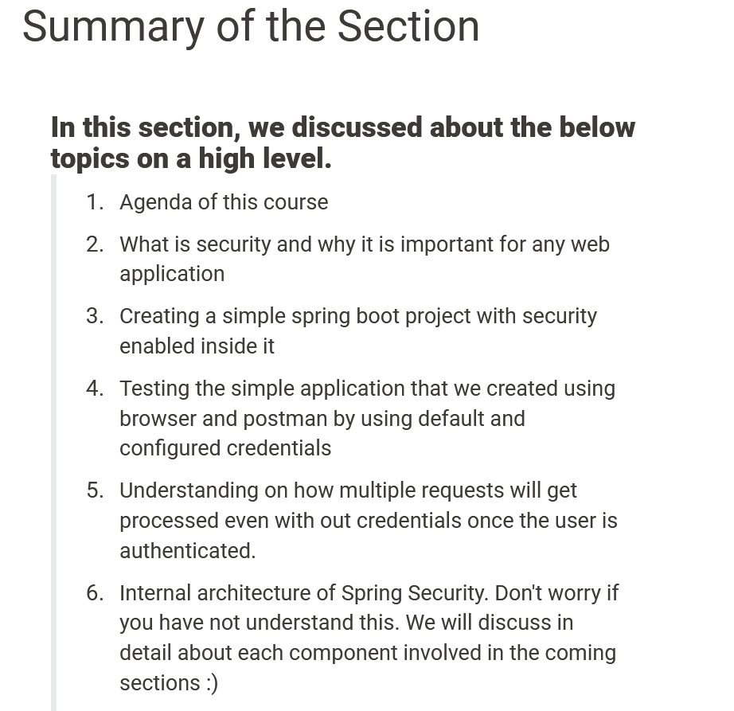
2. 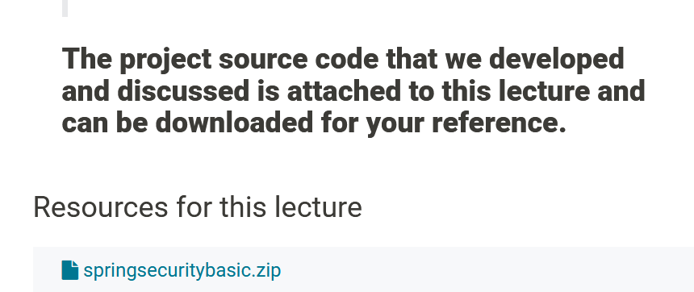
3. <https://att-c.udemycdn.com/2020-09-27_13-10-57-47a9671bc43a3d2bd1df19bfa9e746d1/original.zip?response-content-disposition=attachment%3B+filename%3Dspringsecuritybasic.zip&Expires=1626220858&Signature=AOVnUyBFmUl97pPK1FTQOSAmT6EtgBGMMwHzCjOTNldtG61fqt~OA56ejHU-qa0TvMHuX8rY07PQnwNdEZ1vJ8JOxYshjOsIj-2IIFVv~7qbBFEk1XN0OjFmO5S-XM6vjCfzH~8EkG3fKqNqOE5e0JCZxx4HxQK6p6SP2q95Zir9iQ8oXyVEgOITsCTWypvvTHO~AdBIh4F6EX-MIi~h0Ee648DVYXHrK0fVq~HKR00dlpLGfgyB7Oc2orHOujO97~Xv98vAS21YUZ58x4whkDKE7HbNQ75oIkW1z4b~q1jBZzfls2zBuWVuVU0CFB87zvPJzW86T3KvMpBXLO9Jmg__&Key-Pair-Id=APKAITJV77WS5ZT7262A>